This self assessment questionnaire is to aid Basic Trainers Course applicants to formatively assess their practices readiness to become a GP Training Environment and also their own readiness to become a GP Trainer. A full guidance document, ‘Criteria for GP Specialty Training’ is available for guidance from the Deanery Website and the E-learning portal of BTC.

Please use the numerical scale to self assess (even if your practice is already approved) and write notes on specific areas for improvement for your own guidance. This document can be used to support your inter-modular work as evidence of self-assessment. The Action Planning Grid at the end of the document will help to prioritise and address areas for improvement.

The document is based on the criteria for GP Training domains as indicated below:
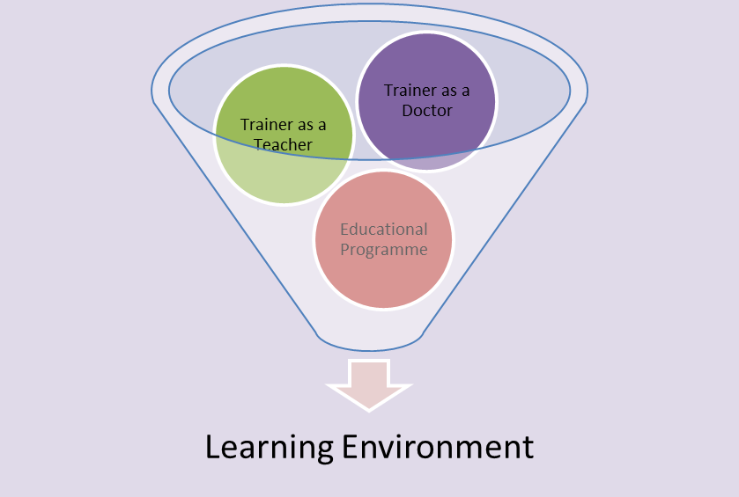

Learning Environment
Evaluation Criteria | Descriptors | Level of Readiness & Notes for Improvement
Premises & Equipment | Adequate, appropriate and must comply with health and safety and accessibility. Learner should have own room , well equipped for consulting and adequate diagnostic and video recording Equipment
  Poor |  |  | Marginal |  |  | Good |  |  | Excellent
  1 | 2 | 3 | 4 | 5 | 6 | 7 | 8 | 9 | 10 | 11 | 12
Records and IT | Records summarised over 95% to enable the Trainee to work and learn safely. Appropriately plans in place to ensure safety. Clear induction plans for IT to ensure learner has full understanding of its potential.
  Poor |  |  | Marginal |  |  | Good |  |  | Excellent
  1 | 2 | 3 | 4 | 5 | 6 | 7 | 8 | 9 | 10 | 11 | 12
Multi-professional Teams | Partners and multi -professional teams that have full understanding of GP Specialty Training as well as familiarity with the GP learner’s curriculum and assessment needs as appropriate.
  Poor |  |  | Marginal |  |  | Good |  |  | Excellent
  1 | 2 | 3 | 4 | 5 | 6 | 7 | 8 | 9 | 10 | 11 | 12
Educational Resources | Appropriately stocked and accessible Library and electronic resources as per Deanery Criteria.
  Poor |  |  | Marginal |  |  | Good |  |  | Excellent
  1 | 2 | 3 | 4 | 5 | 6 | 7 | 8 | 9 | 10 | 11 | 12
Access to Relevant services | The Trainee should have access to appropriate allied services and primary health care team members. This information should be available for learners from the start.
  Poor |  |  | Marginal |  |  | Good |  |  | Excellent
  1 | 2 | 3 | 4 | 5 | 6 | 7 | 8 | 9 | 10 | 11 | 12
Workload and Work Quality | Working patterns and intensity of work must be appropriate for learning (neither too light nor too heavy) with appropriate case mix and exposure to Chronic Disease Management.  While the Trainee should always consider the needs of the patient, they should not be routinely involved in activities of little or no educational value.
  Poor |  |  | Marginal |  |  | Good |  |  | Excellent
  1 | 2 | 3 | 4 | 5 | 6 | 7 | 8 | 9 | 10 | 11 | 12
Health and Safety | All posts and programmes must comply with European Working time Directive, Disability Discrimination Act Data protection and Freedom of Information Act.  The service provider will have a good knowledge of identifying, supporting and managing trainees in difficulty with support from the Training organisations.
  Poor |  |  | Marginal |  |  | Good |  |  | Excellent
  1 | 2 | 3 | 4 | 5 | 6 | 7 | 8 | 9 | 10 | 11 | 12
Governance : Audit and SEA | The Trainer and practice team will be routinely involved in clinical audit and significant incident evaluations and will encourage/support the learner’s involvement in clinical governance processes.
  Poor |  |  | Marginal |  |  | Good |  |  | Excellent
  1 | 2 | 3 | 4 | 5 | 6 | 7 | 8 | 9 | 10 | 11 | 12

The Trainer/ Supervisor(s)
Evaluation Criteria | Descriptors | Level of Readiness & Notes for Improvement
Experience, Qualifications and Clinical competence | Must have adequate GP experience. Must have passed MRCGP and be a member of RCGP in Good standing.
  Poor |  |  | Marginal |  |  | Good |  |  | Excellent
  1 | 2 | 3 | 4 | 5 | 6 | 7 | 8 | 9 | 10 | 11 | 12
Personal and Professional Values | Demonstrate commitment to the ‘Good Medical Practice’ and ‘Duties of a Doctor’. Must possess high professional values and must declare any performance related issues ( past or current)
  Poor |  |  | Marginal |  |  | Good |  |  | Excellent
  1 | 2 | 3 | 4 | 5 | 6 | 7 | 8 | 9 | 10 | 11 | 12
Availability and Accessibility | The Trainer/Supervisor(s) must be available and accessible as appropriate. The prospective Trainer must ensure adequate time for preparation and delivery of protected teaching as well as time for daily supervision/ debrief. The leaner should be adequately supervised to ensure patient safety.
  Poor |  |  | Marginal |  |  | Good |  |  | Excellent
  1 | 2 | 3 | 4 | 5 | 6 | 7 | 8 | 9 | 10 | 11 | 12
Communication skills and working in teams | Demonstrate good communication skills and team working ability.
  Poor |  |  | Marginal |  |  | Good |  |  | Excellent
  1 | 2 | 3 | 4 | 5 | 6 | 7 | 8 | 9 | 10 | 11 | 12
Commitment to Critical appraisal and change management | The Trainer/Supervisor(s) should demonstrate commitment to audit, SEA and other critical appraisal and change management tools.
  Poor |  |  | Marginal |  |  | Good |  |  | Excellent
  1 | 2 | 3 | 4 | 5 | 6 | 7 | 8 | 9 | 10 | 11 | 12
Health | Should declare any health related issues that may impair ability to teach and assess.
  Poor |  |  | Marginal |  |  | Good |  |  | Excellent
  1 | 2 | 3 | 4 | 5 | 6 | 7 | 8 | 9 | 10 | 11 | 12
Teaching and Supervision skills | Must have received adequate training in teaching and supervision skills as appropriate to the needs of the learner. Must have completed BTC. Must be able to demonstrate familiarity to the formative and summative assessment tools and the GP curriculum
  Poor |  |  | Marginal |  |  | Good |  |  | Excellent
  1 | 2 | 3 | 4 | 5 | 6 | 7 | 8 | 9 | 10 | 11 | 12

Educational Programme
Evaluation Criteria | Descriptors | Level of Readiness & Notes for Improvement
Equality and Diversity | The learner must be treated in accordance to the acceptable equality and diversity practices abided by NHS organisations. All the members of the team providing the learning environment will have undergone Equality and Diversity training.
  Poor |  |  | Marginal |  |  | Good |  |  | Excellent
  1 | 2 | 3 | 4 | 5 | 6 | 7 | 8 | 9 | 10 | 11 | 12
Induction | A structured induction programme will be in place to familiarise the learner to the environment and also the local aspects of the service provider. The induction pack will be accessible as an electronic file or a hard copy for the trainee to access throughout their placement.
  Poor |  |  | Marginal |  |  | Good |  |  | Excellent
  1 | 2 | 3 | 4 | 5 | 6 | 7 | 8 | 9 | 10 | 11 | 12
Educational Contract | An explicit educational contract will be in place between the learner the supervising team to ensure both parties engage completely with the teaching and assessment process
  Poor |  |  | Marginal |  |  | Good |  |  | Excellent
  1 | 2 | 3 | 4 | 5 | 6 | 7 | 8 | 9 | 10 | 11 | 12
Varied Training Experience | The programme will ensure adequate variety of exposure so the learner understands the various aspects of the patient journey from primary to secondary care.
  Poor |  |  | Marginal |  |  | Good |  |  | Excellent
  1 | 2 | 3 | 4 | 5 | 6 | 7 | 8 | 9 | 10 | 11 | 12
Organised Programme linked to GP curriculum | The programme must ensure that clinical care is valued for its training opportunities and learning and teaching are well organised and seamlessly integrated into the service provision.
  Poor |  |  | Marginal |  |  | Good |  |  | Excellent
  1 | 2 | 3 | 4 | 5 | 6 | 7 | 8 | 9 | 10 | 11 | 12
Study Leave | Learners must be able to access training days and able to negotiate study leave with the training provider in accordance to local processes as designated in the programme criteria and their contract. While they need to learn to work as part of the team and are not strictly supernumary they do need to given adequate pastoral support and protected time to learn.
  Poor |  |  | Marginal |  |  | Good |  |  | Excellent
  1 | 2 | 3 | 4 | 5 | 6 | 7 | 8 | 9 | 10 | 11 | 12
Supervision and Feedback | The training provider will ensure all involved in training and supervision understand the principles of teaching and assessment relevant to the learner. Adequate training on basic principles of supervision and feedback must be given to all partners/ team concerned in training.
  Poor |  |  | Marginal |  |  | Good |  |  | Excellent
  1 | 2 | 3 | 4 | 5 | 6 | 7 | 8 | 9 | 10 | 11 | 12
Multi-professional input | The educational programme will ensure multi-professional input and in the work place based learning and the opportunity for the learner to learn from and work with the team and be given appropriate support and feedback
  Poor |  |  | Marginal |  |  | Good |  |  | Excellent
  1 | 2 | 3 | 4 | 5 | 6 | 7 | 8 | 9 | 10 | 11 | 12
Overall effectiveness | The service and the educational programme will be approved by the GP training school through its nominated officers for its overall balance and effectiveness in order to confirm PMETB approval. The leads within the learning environment will participate fully in the process of approval and re-approval to ensure continuing quality assurance and management.
  Poor |  |  | Marginal |  |  | Good |  |  | Excellent
  1 | 2 | 3 | 4 | 5 | 6 | 7 | 8 | 9 | 10 | 11 | 12

Action Plan

 | Areas Requiring Development | Resources Available | Person Responsible | Time for completion
1

2

3

4

5

6

7

 | Areas Requiring Development | Resources Available | Person Responsible | Time for completion
8

9

10

11

12

13

